Brandon Dooley

Dooleyb1@tcd.ie

Date of Experiment: 18/11/2016

Lab Session: 14:00-16:00

*All circuit diagrams created using CircutDiagram*

*© 2016 Circuit Diagram*

Brandon Dooley ( #16327446 )

CS1025 Laboratory Experiment 1

CS1025 Laboratory Experiment 1

# Objective

The objective of this experiment was to verify Kirchoff’s Voltage and Current Laws using the following circuits below. It is the objective of this report to prove the following hypotheses to be true:

* **Kirchoffs Voltage Law:** The algebraic sum of branch voltages around any loop in an electrical circuit is equal to zero at every instant in time.
* **Kirchoffs Current Law:** The algebraic sum of electrical currents at any node in an electrical circuit is equal to zero at every instant in time.

# Method (Part One)

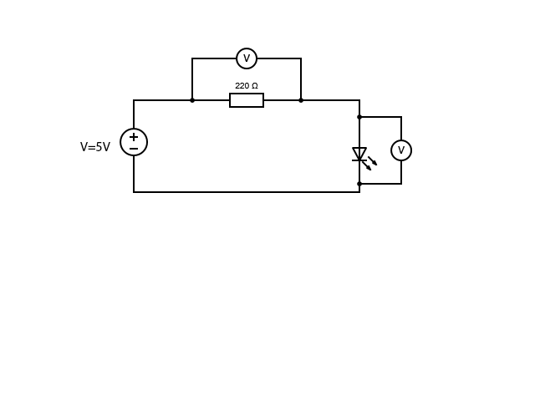 ***Fig 1.1***

The apparatus were set up as shown in *Fig 1.1*, with a 220Ω resistor connected in series with a standard LED. The circuit was then connected to a 5V d.c power supply and current was allowed to flow through the circuit. Using a voltmeter connected in parallel with both the resistor and the LED the respective voltage drops were measured.

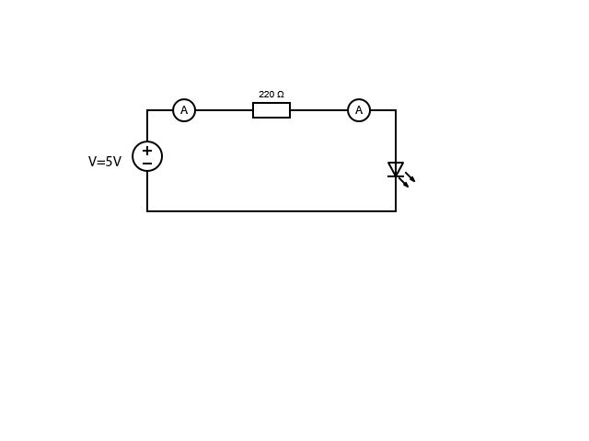 ***Fig 1.2***

The voltmeters were then disconnected and two ammeters placed in series with the components as seen in *Fig 1.2*. The respective currents flowing through each component were then measured and the results recorded.

# Results (Part One)

|  |  |  |  |  |  |
| --- | --- | --- | --- | --- | --- |
| Vin (V) | VResistor (V) | VLED (V) | Iin (mA) | IResistor (mA) | ILED(mA) |
| 5 | 3.19 | 1.78 | 14.6 | 14.1 | 13.8 |

# Analysis (Part One)

* **Kirchoffs Voltage Law:** The algebraic sum of branch voltages around any loop in an electrical circuit is equal to zero at every instant in time.

i.e $$\sum_{loop}{V}=0$$

∴ Vin + (-VLED) + (-VResistor) = 0

Vin = VLED + VResistor

5 = 3.19 + 1.78

5V ≈ 4.97V

* **Kirchoffs Current Law:** The algebraic sum of electrical currents at any node in an electrical circuit is equal to zero at every instant in time.

i.e

$$\sum{I (node)}=0$$

∴ Iin = IResistor = ILED

0.0146A ≈0.0141A ≈ 0.0138A

# Uncertainty & Error (Part One)

* Tolerance errors in the ammeter/voltmeter not giving results to desired degree of accuracy
* Internal resistance of the ammeter/voltmeter impacting on the results as it has a direct impact on the voltages and currents
* Power lost through other energy conversions e.g heat
* Human errors such as inaccuracy taking measurements and mechanical errors whilst taking the actual measurements

# Conclusions(Part One)

* **Kirchoffs Voltage Law:** It can be said that the above circuit holds true for **Kirchoffs Voltage Law** and proves the stated hypothesis within 0.006% tolerance of experimental errors.
* **Kirchoffs Current Law:** It can also be said that the above circuit holds true for **Kirchoffs Current Law** and proves the stated hypothesis within reason and taking into account experimental errors.

# Method (Part Two)

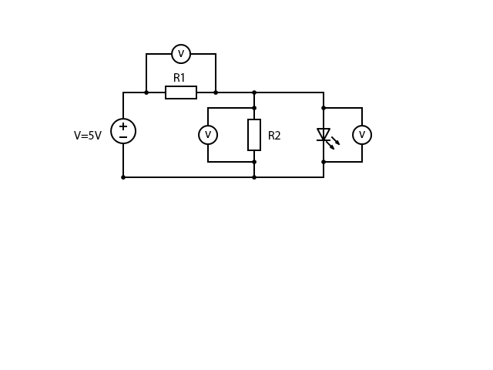***Fig 2.1***

The apparatus was set up as shown in *Fig 2.1* with a 220Ω resistor a(R1) connected in series to a power supply and also connected to a resistor (R2) in parallel with an LED. The circuit was then connected to a 5V d.c power supply and current was allowed to flow through the circuit. Using a voltmeter connected in parallel with both of the resistors and the LED the respective voltage drops were measured. The voltmeters were then disconnected and two ammeters placed in series with the components as seen in *Fig 2.2*. The respective currents flowing into each component were then measured and the results recorded.

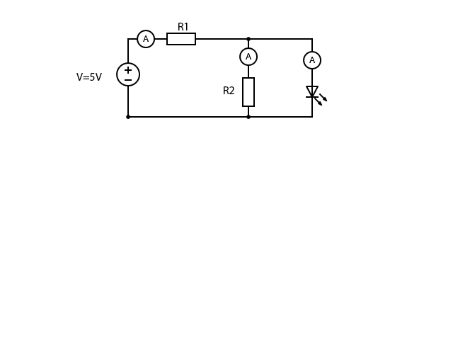 ***Fig 2.2***

The resistor R2 was varied between 50Ω, 100Ω and 220Ω and the above steps were repeated with the voltage drops across, and the current through all elements being measured and recorded each time.

# Results (Part Two)

|  |  |  |  |  |  |
| --- | --- | --- | --- | --- | --- |
| RR1 (Ω) | RR2 (Ω) | Vin (V) | VR1 (V) | VR2 (V) | VLED (V) |
| 220 | 50 | 5 | 4.07 | 0.922 | 0.921 |
| 220 | 100 | 5 | 3.46 | 1.53 | 1.55 |
| 220 | 220 | 5 | 3.21 | 1.77 | 1.77 |

|  |  |  |  |  |  |
| --- | --- | --- | --- | --- | --- |
| RR1 (Ω) | RR2 (Ω) | Vin (V) | IR1 (mA) | IR2 (mA) | ILED (mA) |
| 220 | 50 | 5 | 18.5 | 18.1 | 0.0 |
| 220 | 100 | 5 | 15.9 | 15.4 | 0.2 |
| 220 | 220 | 5 | 14.6 | 8.1 | 6.6 |

# Analysis (Part Two)

* **Kirchoffs Voltage Law:** The algebraic sum of branch voltages around any loop in an electrical circuit is equal to zero at every instant in time.

i.e $$\sum_{loop}{V}=0$$

∴ Vin + (-VR1) + (-VR2 || VLED ) = 0

Vin = VR1 + (VR2 || VLED )

|  |  |  |  |  |  |
| --- | --- | --- | --- | --- | --- |
| RR2 (Ω) | Vin (V) | VR1 (V) | VR2 (V) | VLED (V) | VR1 + (VR2 || VLED )  (V) |
| 50 | **5** | 4.07 | 0.922 | 0.921 | **4.99** |
| 100 | **5** | 3.46 | 1.53 | 1.55 | **5.01** |
| 220 | **5** | 3.21 | 1.77 | 1.77 | **4.98** |

* **Kirchoffs Current Law:** The algebraic sum of electrical currents at any node in an electrical circuit is equal to zero at every instant in time.

i.e

$$\sum{I (node)}=0$$

∴ IR1 + (-IR2)+ (-ILED) =0

IR1 = IR2 + ILED

|  |  |  |  |  |  |
| --- | --- | --- | --- | --- | --- |
| RR2 (Ω) | Vin (V) | IR1 (mA) | IR2 (mA) | ILED (mA) | IR1 = IR2 + ILED  (mA) |
| 50 | 5 | **18.5** | 18.1 | 0.0 | **18.1** |
| 100 | 5 | **15.9** | 15.4 | 0.2 | **15.6** |
| 220 | 5 | **14.6** | 8.1 | 6.6 | **14.7** |

# Uncertainty and Error (Part Two)

* Tolerance errors in the ammeter/voltmeter not giving results to desired degree of accuracy
* Internal resistance of the ammeter/voltmeter impacting on the results as it has a direct impact on the voltages and currents
* Power lost through other energy conversions e.g heat
* Human errors such as inaccuracy taking measurements and mechanical errors whilst taking the actual measurements

# Conclusions(Part Two)

* **Kirchoffs Voltage Law:** From the above tables and results it is safe to say that Kirchoffs Voltage Law does hold true for the circuits seen in *Fig 2.1* and *Fig 2.2*. Although the results are not entirely what the hypothesis stated, taking into account experimental error’s it can be said that the hypothesis has been proven true. Therefore, the algebraic sum of branch voltages around any loop in an electrical circuit is equal to zero at every instant in time.
* **Kirchoffs Current Law:** Similar to Kirchoffs Voltage Law it is safe to say that Kirchoffs Current Law also holds true for the circuits seen in *Fig 2.1* and *Fig 2.2*. Allowing for reasonable experimental errors it can be stated with confidence that the hypothesis has been proven true; the algebraic sum of electrical currents at any node in an electrical circuit is equal to zero at every instant in time.
* **LED Operation:** It was also noted that in part two of the experiment the intensity of the light emitted from the LED directly depended on the resistor placed in parallel with it. The initial 50Ω resistor caused little if any light to be emitted. This was because the current took the past of least resistance and flowed through the resistor rather than the LED. However, when the 220Ω resistor was put in instead, the LED emitted a large amount of light as more current now flowed through the LED. Therefore it can be stated that current flows through desirable paths of least resistance throughout a circuit.
* **Voltage Drops Across Parallel Branches:** It can also be concluded that voltage is evenly distributed or dropped across parallel branches in a circuit. i.e

(VR2 || VLED )

VR2 = VLED

* **Current Through Parallel Branches:** It can also be concluded that the sum of currents flowing through a parallel branch is equal to the current entering the branch (*Principle Conservation of Energy*) i.e

Iin = IR2 + ILED